 | SAKR MANNING AGENCY  FOR RECRUITING EGYPTIAN LABOR ABROAD | Issue Date | 15.05.2022
 |  | Revision Date | 27.05.2023
 | Crewing Management Manual  Seafarer Employment Application | Revision | 1.2
 |  | Page | 3
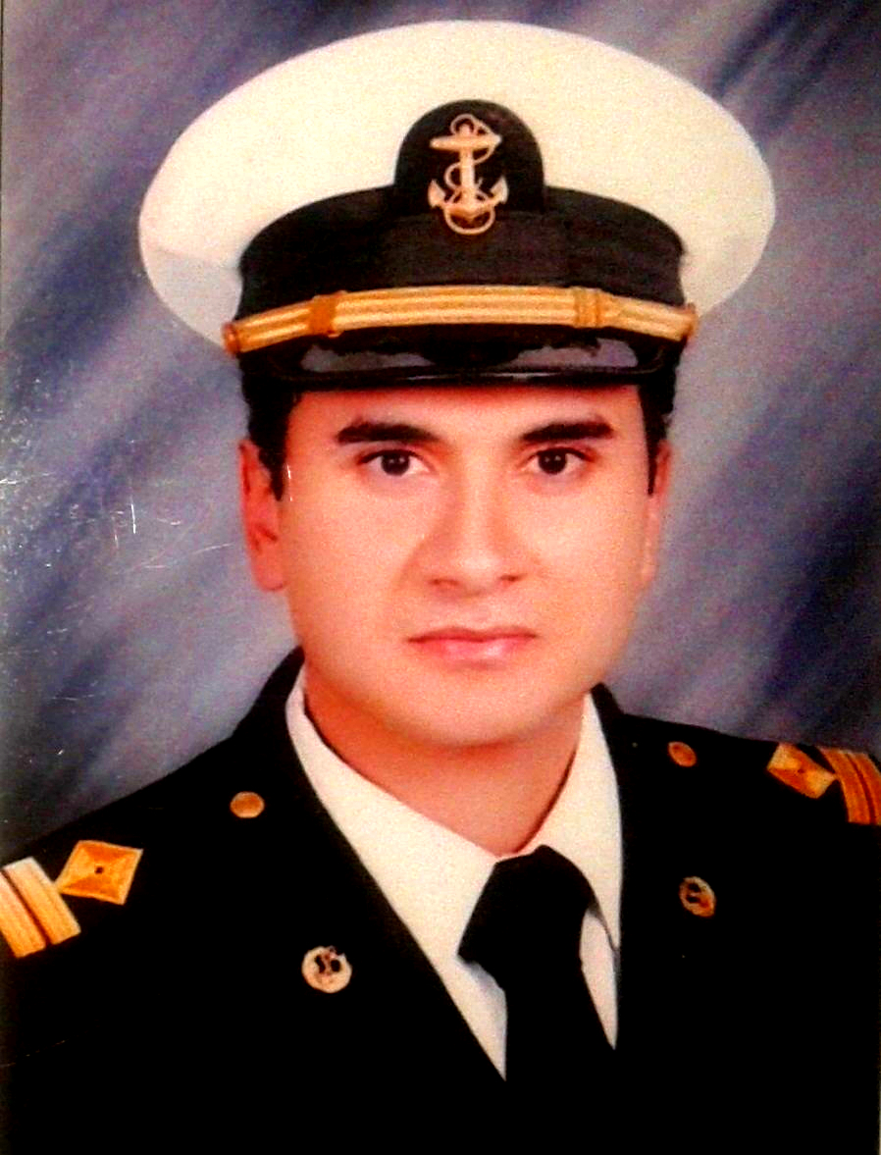
Application For Position as | Third Engineer  third engineer,  third engineer,
Register Code. | EO-3.096
Other Position (If Any)
Register Date | 28/11/2023
Last up Date Data
Expected Salary | 3000 USD

1. PERSONAL DETAILS
Full Name |  | Ibrahim Mohsen Ali Elsayed
Date Of Birth |  | 01.02.1983 |  |  |  |  |  | Place Of Birth |  |  |  |  |  |  | Egypt
Nationality |  | Egyptian  Egyptian |  |  |  |  |  | Marital Status |  |  |  |  |  |  | Single |  |  |  |  |  |  | Married
Height (Cm) |  | 182 |  |  |  |  |  | Overall Size |  |  |  |  |  |  | XXL |  |  |  |  | Shirt Size
Weight (Kg) |  | 80 |  |  |  |  |  | Trouser Size |  |  |  |  |  |  |  |  |  |  |  | Shoes Size |  |  |  |  | 45
2. EDUCATION
College / School |  | Faculty of Engineering – Alexandria University  Faculty of Engineering – Alexandria University,
Marline Test |  | Issued Date |  |  |  | Result % |  |  |  | Issued By (Authority) |  |  |  |  |  |  |  |  | Issued At
 |  | August 2023 |  |  |  | 93 |  |  |  | Pan Arab |  |  |  |  |  |  |  |  | Egypt
English Language |  | Fluent |  |  |  |  | Good |  |  |  |  | Average |  |  |  |  |  |  | Poor
Arabic Language  ( ) |  | Fluent |  |  |  |  | Good |  |  |  |  | Average |  |  |  |  |  |  | Poor
3. CONTACT DETAILS
Home Address / City |  | Alexandria – Egypt  haleem_7afez@yahoo.com
E-Mail |  | haleem_7afez@yahoo.com |  |  |  |  |  |  | Mobile / Tel |  |  |  |  | +2 012 0840 7786

4. TRAVEL DOCUMENTS
Type |  | Document No. |  |  | ISS. Date |  |  | Exp. Date |  |  |  |  | ISS. By (Authority) |  |  |  |  |  |  |  |  | Place of Issue
Passport |  | A30847851 |  |  | 04.07.2022 |  |  | 03.07.2029 |  |  |  |  | Egyptian Authority |  |  |  |  |  |  |  |  | Egypt
Seaman Book |  | S00031803 |  |  | 11.06.2023 |  |  | 08.05.2028 |  |  |  |  | EAMS |  |  |  |  |  |  |  |  | Alex.
Other Seaman Book |  | 801351 |  |  | 16.06.2021 |  |  | 15.05.2026 |  |  |  |  | MI maritime office |  |  |  |  |  |  |  |  | MI

5. PROFESSIONAL QUALIFICATION / CERTIFICATE OF COMPETENCY
Certificate Name |  |  |  | Number | Issue Date |  |  |  |  |  | Expiry Date |  |  |  |  | Issued By |  |  |  |  |  |  |  | Issued At
COC ( Rank) 3rd engr |  |  |  | 3246 | 06.06.2023 |  |  |  |  |  | 08.05.2028 |  |  |  |  | EAMS |  |  |  |  |  |  |  | Alex.
GOC
D.P. INDUCTION
D.P. ADVANCED
D.P. OPERATOR (UNLIMITED)
6. NEXT OF KIN
Full Name | Muhammed Mohsen Ali |  |  |  |  |  |  |  |  |  |  |  |  | Relationship |  |  |  | Brother
Address | Alexandria – Egypt
Tel. No. |  |  |  |  |  |  |  |  | Mobile |  |  | +2 012 0840 7786
7. HEALTH CERTIFICATES & VACCINATIONS
Flag State |  |  | Number |  |  | Issue Date |  |  |  |  | Expiry Date |  |  |  |  |  | Issued By |  |  |  |  |  | Issued At
International Medical |  |  |  |  |  | 18.06.2023 |  |  |  |  | 17.06.2025 |  |  |  |  |  | EAMS |  |  |  |  |  | Alex.
Yellow Fever |  |  |  |  |  | 02.06.2009 |  |  |  |  | XXX |  |  |  |  |  | Ministry of Health |  |  |  |  |  | Alex.
Cholera
Covid-19 |  |  | Vaccination Name |  |  | First Dose |  |  |  |  | Second Dose |  |  |  |  |  | (Other Does or Remarks)
 |  |  | Pfizer&Astrazeneca |  |  | 31.07.2021 |  |  |  |  | 28.09.2021

8. MARINE COURSES
Course Name | Number | Issue Date | Expiry Date | Issued By / At
Personal Survival Techniques
Proficiency In Personal Survival Techniques | XNPST1664 | 13.05.2023 | 07.05.2028 | Egypt
Fire Prevention and Fire Fighting
Advanced Fire Prevention and Fire Fighting | XNAFF546 | 17.05.2023 | 14.05.2028 | Egypt
Elementary First Aid | XNFA1656 | 16.05.2023 | 10.05.2028 | Egypt
Medical Care Studies
Personal Safety and Social Responsibilities | XNPS1761 | 13.05.2023 | 07.05.2028 | Egypt
Proficiency Of Security Awareness Training Seafarers | XNA3036 | 25.05.2023 | 16.05.2028 | Egypt
Proficiency as a ship Security officer ( PSSO )
Proficiency In Survival Craft & Rescue Boats | XNC1818 | 16.05.2023 | 10.05.2028 | Egypt
G.M.D.S.S
Communications
Advanced Communications
ECDIS Advanced Simulator (Management Level)
ECDIS Simulator (Operation Level)
Prevention and Combating of Marine Pollution | 29135/13/EG | 08.07.2013 | XXXXXXX | Egypt
Radar & ARPA Simulator and Search &rescue
ARPA Simulator and Search
Marine Radar and automatic Radar Plotting
Bridge resource Management (B.R.M)
Engine resource Management (E.R.M)
Navigational Watch keeping
Proficiency for Rating forming part of Navigational watch (II/4) |  |  |  | EAMS / Alex.
High voltage training – operation of ship (1000 Volt and More)
Passenger Safety Cargo Safety and Hull integrity
Crowd Management Training
Crisis Management and Human Behavior Training
Safety training for Personal Prov. Direct Passengers
Practical Ability to Prepare Meals and (MLC 2006)
Personal Hygiene and Envir. Protection (MLC 2006)
Safety and Health in the Provision Meals (MLC 2006)
Food Storage and inventory Control (MLC 2006)
Ships Cook Certificate (MLC 2006) |  |  |  | EAMS / Alex.
Abel Seafarer Deck
Proficiency for Abel Seafarer Deck ( II/5 ) |  |  |  | EAMS / Alex.
Engineering Watch keeping |  |  |  | EAMS / Alex.
Proficiency for Rating forming part of a watch in engine room
Abel Seafarer Engine
Proficiency for Abel Seafarer Engine ( III/5 ) |  |  |  | EAMS / Alex.
Electro Technical Rating
Proficiency for Electro Technical rating ( III/7 ) |  |  |  | EAMS / Alex.

 |  |  | COMPLETE SEA – SERVICE DETAILS
Name: |  |  |  |  |  |  |  |  |  |  |  |  |  | Rank: |  |  |  |  | Register Code:
Company Name |  |  |  |  |  | Rank | Vessel Name |  |  | Flag |  |  | Signed On |  |  | Signed Off |  |  | Period | Vessel Type |  |  | D.W.T. |  | Engine Type |  | BH |  |  |  | KW
P&O Maritime Logistics |  |  |  |  |  | 3rd Eng | Topaz Khubayb |  |  | MI |  |  | 04.07.2021 |  |  | 03.11.2021 |  |  | 123 | AHTS-DP2 |  |  | 1340 |  | Caterpillar |  | 5150 |  |  |  | 3840
Maridive and Oil Services |  |  |  |  |  | 3rd Eng | Maridive 230 |  |  | Belize |  |  | 03.08.2019 |  |  | 01.10.2019 |  |  | 60 | AHTS-DP2 |  |  | 1810 |  | Wärtsilä |  | 6000 |  |  |  | 4474
Maridive and Oil Services |  |  |  |  |  | 3rd Eng | Maridive 230 |  |  | Belize |  |  | 26.05.2019 |  |  | 23.06.2019 |  |  | 29 | AHTS-DP2 |  |  | 1810 |  | Wärtsilä |  | 6000 |  |  |  | 4474
Maridive and Oil Services |  |  |  |  |  | 3rd Eng | Maridive 230 |  |  | Belize |  |  | 04.04.2019 |  |  | 28.04.2019 |  |  | 25 | AHTS-DP2 |  |  | 1810 |  | Wärtsilä |  | 6000 |  |  |  | 4474
Maridive and Oil Services |  |  |  |  |  | 3rd Eng | Maridive 518 |  |  | Belize |  |  | 16.01.2019 |  |  | 13.02.2019 |  |  | 29 | AHTS-DP1 |  |  | 1400 |  | Caterpillar |  | 5150 |  |  |  | 3840
Maridive and Oil Services |  |  |  |  |  | 3rd Eng | Maridive 518 |  |  | Belize |  |  | 22.11.2018 |  |  | 20.12.2018 |  |  | 29 | AHTS-DP1 |  |  | 1400 |  | Caterpillar |  | 5150 |  |  |  | 3840
Maridive and Oil Services |  |  |  |  |  | 3rd Eng | Maridive 518 |  |  | Belize |  |  | 27.09.2018 |  |  | 25.10.2018 |  |  | 29 | AHTS-DP1 |  |  | 1400 |  | Caterpillar |  | 5150 |  |  |  | 3840
Maridive and Oil Services |  |  |  |  |  | 3rd Eng | Maridive 518 |  |  | Belize |  |  | 02.08.2018 |  |  | 30.08.2018 |  |  | 29 | AHTS-DP1 |  |  | 1400 |  | Caterpillar |  | 5150 |  |  |  | 3840
Maridive and Oil Services |  |  |  |  |  | 3rd Eng | Maridive 518 |  |  | Belize |  |  | 07.06.2018 |  |  | 05.07.2018 |  |  | 29 | AHTS-DP1 |  |  | 1400 |  | Caterpillar |  | 5150 |  |  |  | 3840
Maridive and Oil Services |  |  |  |  |  | 3rd Eng | Maridive 518 |  |  | Belize |  |  | 12.04.2018 |  |  | 10.05.2018 |  |  | 29 | AHTS-DP1 |  |  | 1400 |  | Caterpillar |  | 5150 |  |  |  | 3840
IPC Marine Services |  |  |  |  |  | 3rd Eng | Mira |  |  | Liberia |  |  | 28.08.2017 |  |  | 27.10.2017 |  |  | 60 | Bulk Carrier |  |  | 49016 |  | MAN B&W |  | 10800 |  |  |  | 8054
Namma Shipping Lines |  |  |  |  |  | 3rd Eng | Alnawa Express |  |  | Saudi Arabia |  |  | 14.04.2015 |  |  | 07.07.2015 |  |  | 85 | RORO -Cargo |  |  | 7154 |  | Krupp MAK |  | 7107 |  |  |  | 5300
Namma Shipping Lines |  |  |  |  |  | 3rd Eng | Masarrah |  |  | Saudi Arabia |  |  | 28.02.2015 |  |  | 07.04.2015 |  |  | 39 | RORO - Passenger |  |  | 1753 |  | Stork Werkspoor |  | 18000 |  |  |  | 13423
Petroleum Marine Services |  |  |  |  |  | 3rd Eng | PMS 17 |  |  | Egypt |  |  | 23.02.2010 |  |  | 04.02.2012 |  |  | 358 | AHTS-Non DP |  |  | 9830 |  | Deutz |  | 8851 |  |  |  | 6600
National Shipping & Investment |  |  |  |  |  | 3rd Eng | Medstar I |  |  | Comoros |  |  | 04.08.2009 |  |  | 16.09.2009 |  |  | 43 | PSV-Non DP |  |  | 643 |  | Resita |  | 4500 |  |  |  | 3356
 |  | SPECIALISED EXPERIENCE
 |  | Name |  |  |  |  |  |  |  |  |  |  |  | Type |  |  |  | From |  |  | To |  |  | Comments
 |  | Marine Surveyor at Fanar marine services, Dubai |  |  |  |  |  |  |  |  |  |  |  | Shore experience |  |  |  | 06.2012 |  |  | 06.2013 |  |  | Conducting different types of marine surveys onboard all types of ships
 |  | I declare that the information I have given is, to the best of my knowledge, true and complete. I also declare that the documents submitted are genuine, given and sign by persons whose names appear on them.
 |  |  |  |  |  |  |  |  |  |  |  |  |  |  |  |  | 19.11.2023 |  |  |  |  |  |  | Ibrahim Mohsen Ali
 |  |  |  |  |  |  |  |  |  |  |  |  |  |  |  |  |  |  | DATE |  |  |  |  |  | SIGNATURE

